# Supplemental Material for the paper: Consolidation and Change: Exploring the Impact of Anger and Attitude Dynamics on Inequality Belief Systems

Table 1: descriptives of mgm and Ising variables

|  |  |  |  |  |  |  |  |  |  |
| --- | --- | --- | --- | --- | --- | --- | --- | --- | --- |
| Statistic | N | Mean | | St. Dev. | | Min | | Max | |
| mgm | Ising | mgm | Ising | mgm | Ising | mgm | Ising |
| p_income | 1,188 | 4.098 | 0.469 | 1.070 | 0.499 | 1 | 0 | 5 | 1 |
| p_tax | 1,188 | 3.642 | 0.629 | 1.167 | 0.483 | 1 | 0 | 5 | 1 |
| b_tax | 1,188 | 4.035 | 0.309 | 0.804 | 0.462 | 1 | 0 | 5 | 1 |
| j_income | 1,188 | 2.881 | 0.709 | 0.791 | 0.455 | 1 | 0 | 4 | 1 |
| j_distrust | 1,188 | 3.997 | 0.341 | 0.943 | 0.474 | 1 | 0 | 5 | 1 |
| j_failure | 1,188 | 3.982 | 0.707 | 0.862 | 0.455 | 1 | 0 | 5 | 1 |
| e_weafam | 1,188 | 2.868 | 0.625 | 1.065 | 0.484 | 1 | 0 | 5 | 1 |
| e_edupar | 1,188 | 3.325 | 0.434 | 0.923 | 0.496 | 1 | 0 | 5 | 1 |
| e_edu | 1,188 | 4.131 | 0.338 | 0.758 | 0.473 | 1 | 0 | 5 | 1 |
| e_work | 1,188 | 4.342 | 0.466 | 0.715 | 0.499 | 1 | 0 | 5 | 1 |
| e_people | 1,188 | 3.460 | 0.463 | 0.904 | 0.499 | 1 | 0 | 5 | 1 |
| e_connec | 1,188 | 2.455 | 0.420 | 1.012 | 0.494 | 1 | 0 | 5 | 1 |
| e_bribes | 1,188 | 1.421 | 0.274 | 0.817 | 0.446 | 1 | 0 | 5 | 1 |
| e_race | 1,188 | 2.145 | 0.380 | 1.126 | 0.485 | 1 | 0 | 5 | 1 |
| e_relig | 1,188 | 1.805 | 0.524 | 0.971 | 0.500 | 1 | 0 | 5 | 1 |
| e_sex | 1,188 | 2.204 | 0.385 | 1.161 | 0.487 | 1 | 0 | 5 | 1 |
| b_public | 1,188 | 3.272 | 0.500 | 1.338 | 0.500 | 1 | 0 | 5 | 1 |
| b_market | 1,188 | 3.641 | 0.619 | 1.094 | 0.486 | 1 | 0 | 5 | 1 |
| b_resp | 1,188 | 4.035 | 0.253 | 0.714 | 0.435 | 1 | 0 | 5 | 1 |
| b_train | 1,188 | 3.625 | 0.571 | 0.868 | 0.495 | 1 | 0 | 5 | 1 |
| b_need | 1,188 | 2.416 | 0.430 | 1.160 | 0.495 | 1 | 0 | 5 | 1 |
| b_merit | 1,188 | 4.327 | 0.445 | 0.699 | 0.497 | 1 | 0 | 5 | 1 |
| anger | 1,188 | 4.918 |  | 2.958 |  | 0 |  | 10 |  |

*Caption:* descriptives of full scale and dummy variables

Figure 1: Comparison of centrality scores in the mgm and Ising models

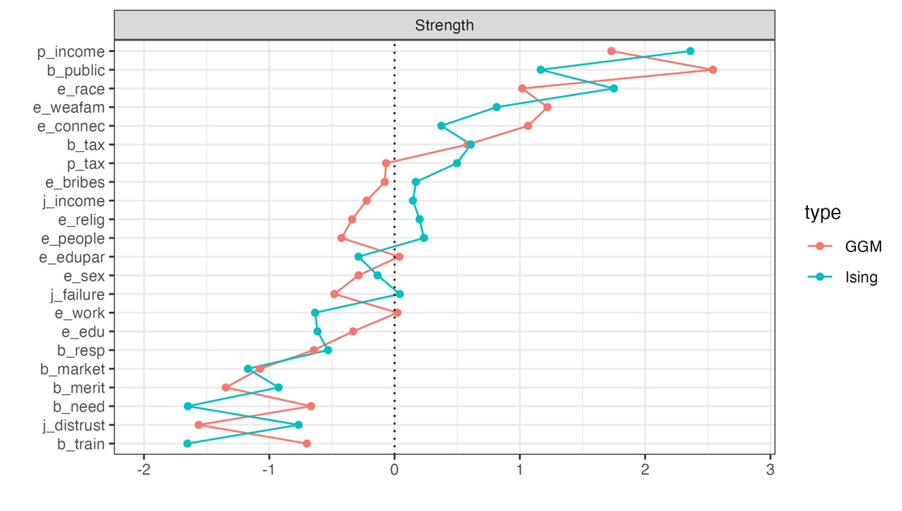

*Caption:* Z-scores of strength centrality in the full scale and dummy model. Centrality scores are remarkably consistent between the two types of network estimations.

Figure 2: robustness of mgm parameters

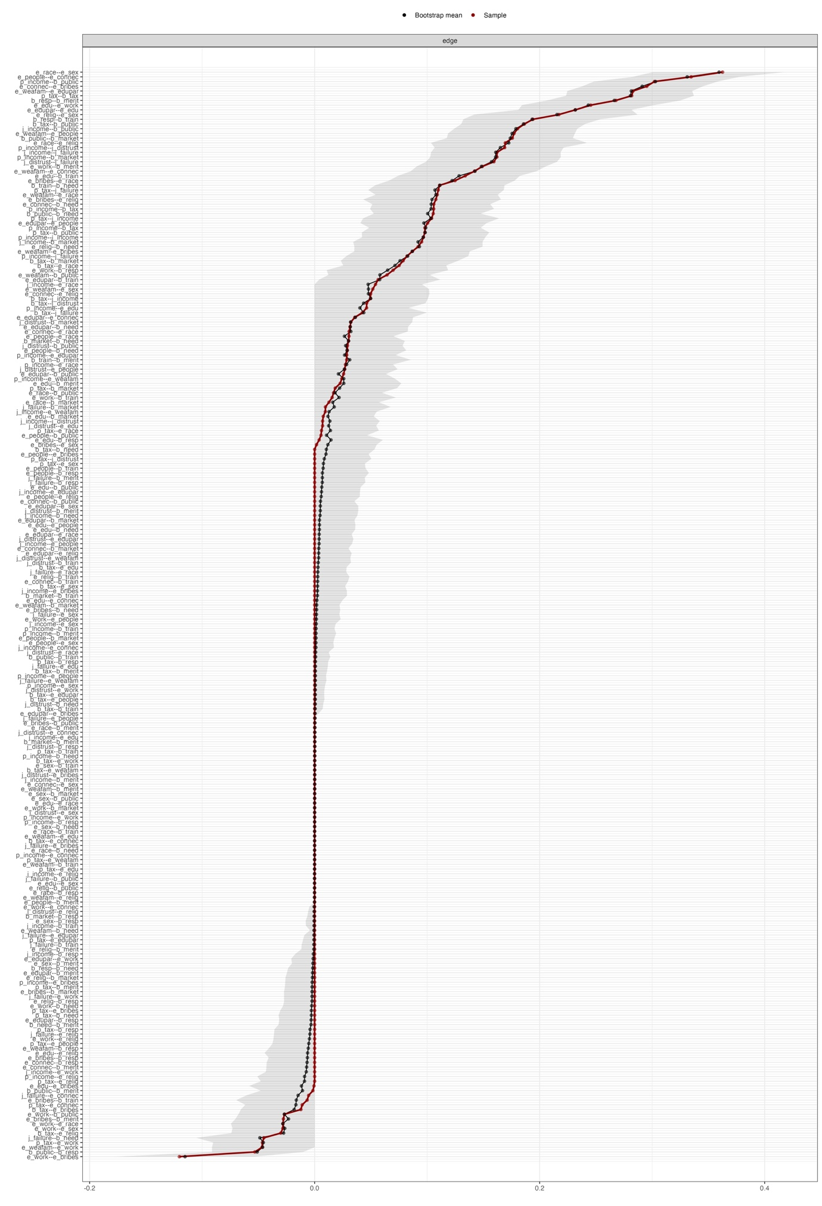

*Caption:* each row represents an edge. Grey areas show bootstrapped CIs. Red dots indicate the magnitudes of the estimated parameters in the original sample, and blue dots indicate the mean value of the parameter estimated across the bootstrapped samples.

Figure 3: centrality stability of the mgm model

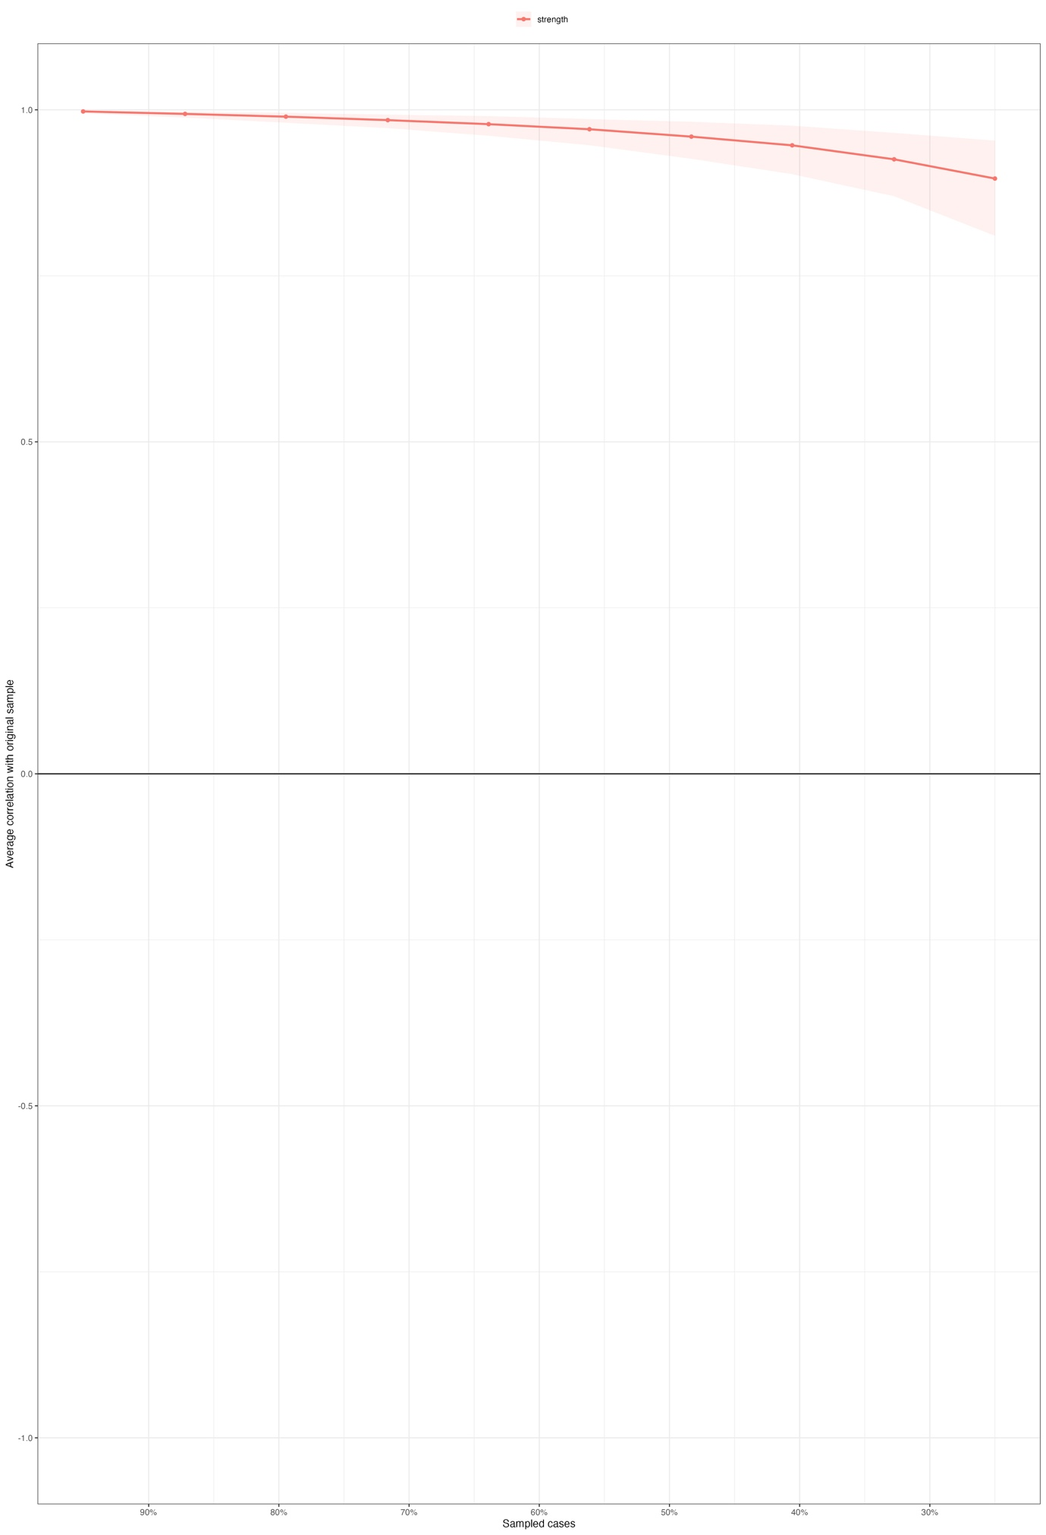

*Caption:* Stability of the centrality estimates of the mgm model. The red area indicates the bootstrapped distribution of strength centrality scores obtained by gradually dropping individuals from the original sample. Scores are remarkably stable.

Table 2: stability of moderation effects

|  |  |  |  |  |  |
| --- | --- | --- | --- | --- | --- |
| Variables | | |Mean effect| | CI low | CI high | % inclusion |
| j_failure | b_public | 0.07 | 0.02 | 0.12 | 0.99 |
| e_weafam | e_sex | 0.06 | 0.01 | 0.1 | 0.97 |
| e_edu | b_market | 0.05 | 0.01 | 0.1 | 0.96 |
| e_edupar | e_race | 0.05 | 0 | 0.1 | 0.95 |
| e_edu | e_bribes | 0.05 | 0.01 | 0.1 | 0.96 |
| e_weafam | e_connec | 0.04 | 0 | 0.09 | 0.91 |
| p_income | b_merit | 0.04 | 0 | 0.1 | 0.81 |
| j_distrust | b_need | 0.04 | 0 | 0.09 | 0.92 |
| e_edupar | b_market | 0.04 | 0 | 0.09 | 0.83 |
| b_tax | e_weafam | 0.04 | 0 | 0.09 | 0.91 |
| e_sex | b_market | 0.04 | 0 | 0.08 | 0.87 |
| e_connec | b_merit | 0.04 | 0 | 0.08 | 0.9 |
| j_failure | b_need | 0.04 | 0 | 0.08 | 0.9 |
| b_tax | e_work | 0.03 | 0 | 0.07 | 0.84 |
| e_people | e_relig | 0.03 | 0 | 0.08 | 0.84 |
| p_income | e_sex | 0.03 | 0 | 0.08 | 0.82 |
| b_tax | e_connec | 0.03 | 0 | 0.07 | 0.82 |
| j_distrust | e_connec | 0.03 | 0 | 0.07 | 0.84 |
| p_income | e_edupar | 0.03 | 0 | 0.07 | 0.9 |
| p_tax | b_need | 0.03 | 0 | 0.06 | 0.88 |
| e_weafam | e_relig | 0.03 | 0 | 0.07 | 0.81 |
| e_work | e_edu | 0.03 | 0 | 0.06 | 0.83 |
| p_tax | b_public | 0.03 | 0 | 0.08 | 0.82 |
| e_weafam | b_need | 0.03 | 0 | 0.08 | 0.83 |
| b_public | e_work | 0.03 | 0 | 0.07 | 0.86 |
| e_people | b_need | 0.02 | -0.01 | 0.06 | 0.81 |
| p_income | b_need | 0.02 | -0.01 | 0.06 | 0.83 |
| j_failure | b_public | 0.01 | -0.04 | 0.05 | 0.83 |

*Caption:* The table shows the absolute values of moderation effects that were found in at least 80% of the bootstrap samples. Node labels of the moderated associations are reported in the first two columns. The third shows the absolute mean value of the estimated moderation effect across the bootstrapped samples. The remaining columns present CI boundaries and the percentage of detection across the resampling procedure.

Figure 4: robustness of Ising parameters

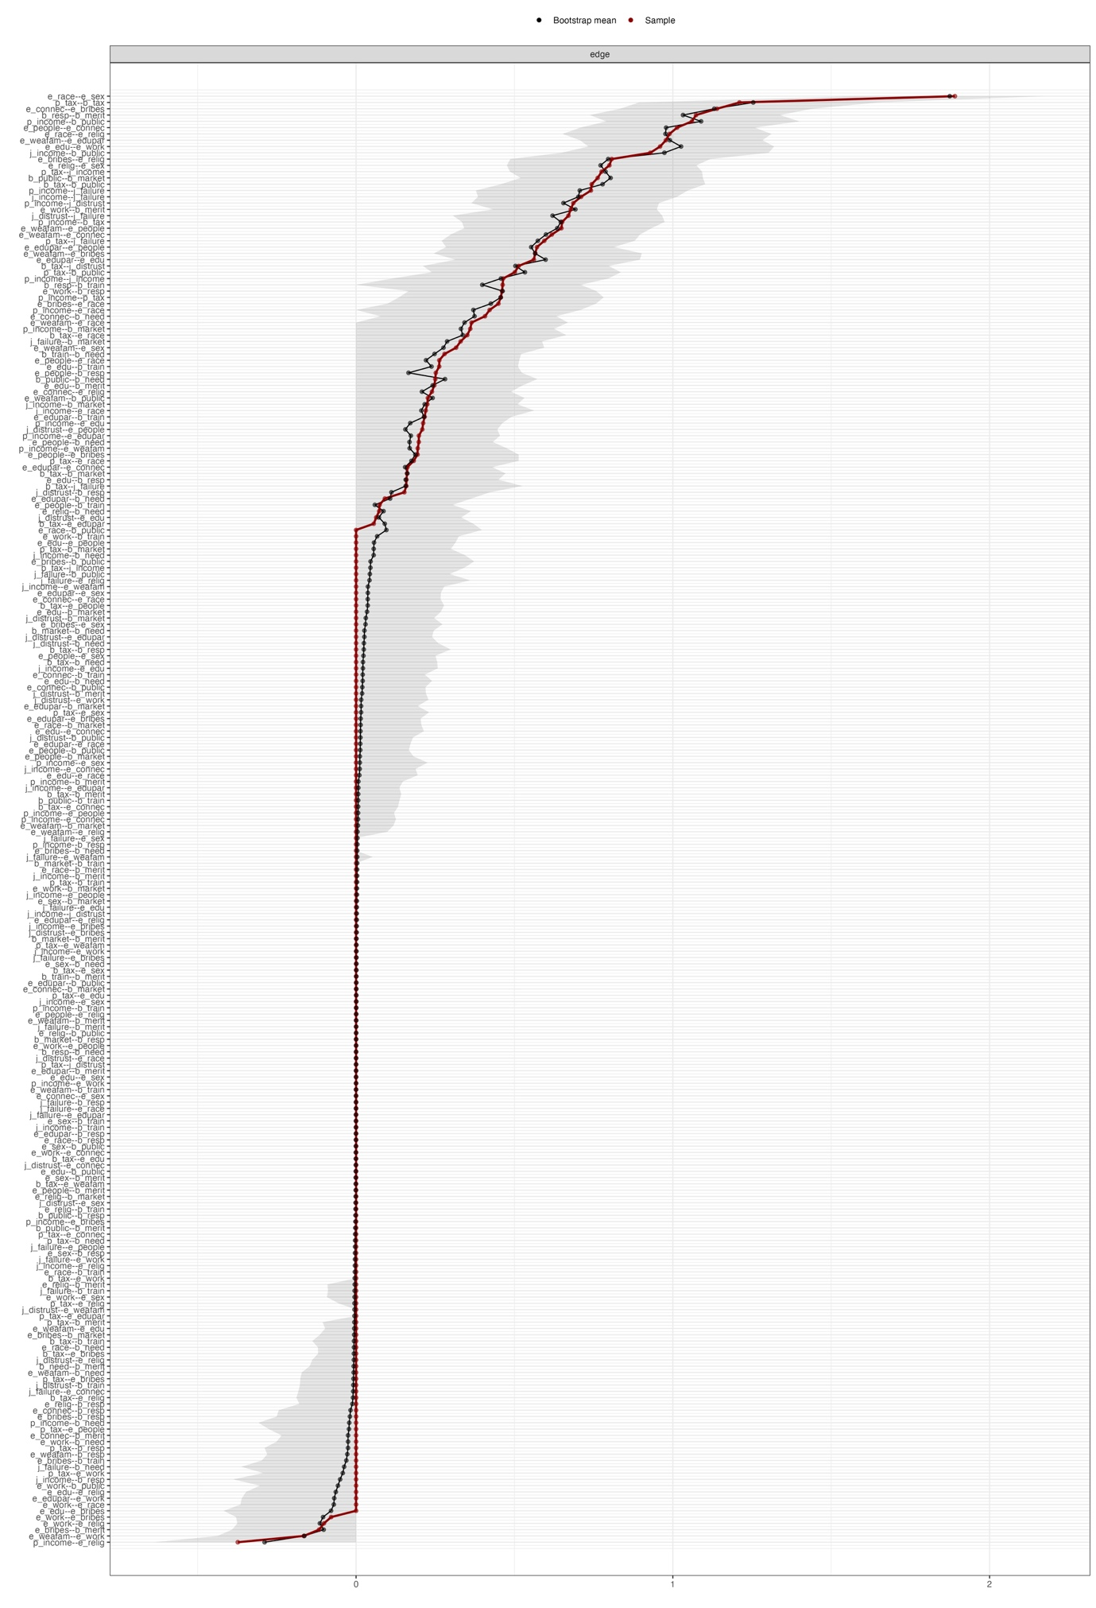

*Caption:* each row represents an edge. Grey areas show bootstrapped CIs. Red dots indicate the magnitudes of the estimated parameters in the original sample, and blue dots indicate the mean value of the parameter estimated across the bootstrapped samples.

Figure 5: centrality stability of Ising model

*Caption:* Stability of the centrality estimates of the Ising model. The red area indicates the bootstrapped distribution of strength centrality scores obtained by gradually dropping individuals from the original sample. Scores are remarkably stable.

Figure 6: Missing map of selected variables

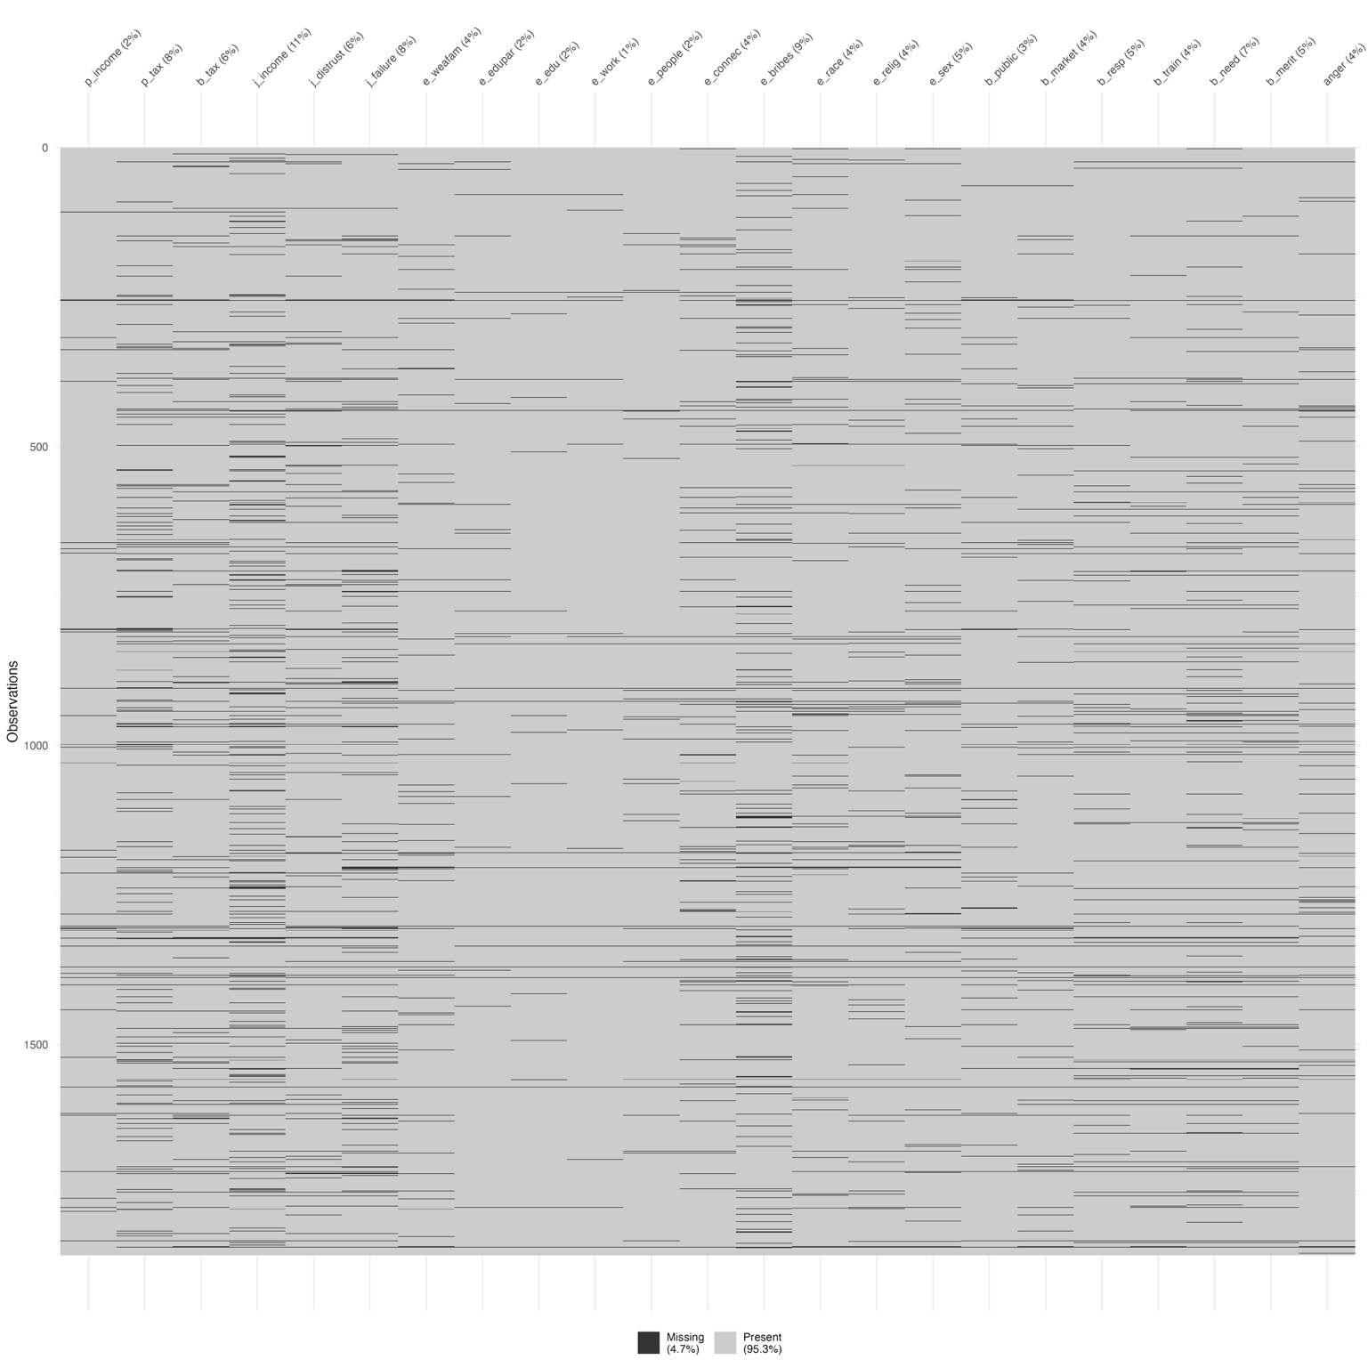

*Caption:* listwise deletion reduces the sample by 4.7%. Most of the missing values are associated with the variable *ineq_j*.

Table 3: T-tests on mean values of selected variables befor and after list-wise deletion

|  |  |  |  |
| --- | --- | --- | --- |
| **Variable** | **Mean Final Sample** | **Mean Full Sample** | **P Value** |
| p_income | 4.098 | 4.04 | 0.142 |
| p_tax | 3.642 | 3.601 | 0.349 |
| b_tax | 4.035 | 3.989 | 0.125 |
| j_income | 2.881 | 2.887 | 0.856 |
| j_distrust | 3.997 | 3.989 | 0.814 |
| j_failure | 3.982 | 3.938 | 0.176 |
| e_weafam | 2.868 | 2.852 | 0.685 |
| e_edupar | 3.325 | 3.314 | 0.762 |
| e_edu | 4.131 | 4.12 | 0.68 |
| e_work | 4.342 | 4.335 | 0.799 |
| e_people | 3.46 | 3.459 | 0.979 |
| e_connec | 2.455 | 2.482 | 0.477 |
| e_bribes | 1.421 | 1.414 | 0.832 |
| e_race | 2.145 | 2.099 | 0.276 |
| e_relig | 1.805 | 1.817 | 0.739 |
| e_sex | 2.204 | 2.174 | 0.492 |
| b_public | 3.272 | 3.187 | 0.088 |
| b_market | 3.641 | 3.597 | 0.287 |
| b_resp | 4.035 | 4.011 | 0.381 |
| b_train | 3.625 | 3.605 | 0.525 |
| b_need | 2.416 | 2.422 | 0.880 |
| b_merit | 4.327 | 4.300 | 0.311 |
| anger | 4.918 | 4.763 | 0.161 |

*Caption:* results of t-tests for detecting significant differences in means. P-values reveal none of the recorded differences between the final and original samples is significant.